Davil’s Zhentarim vs. Urstul’s Zhentarim
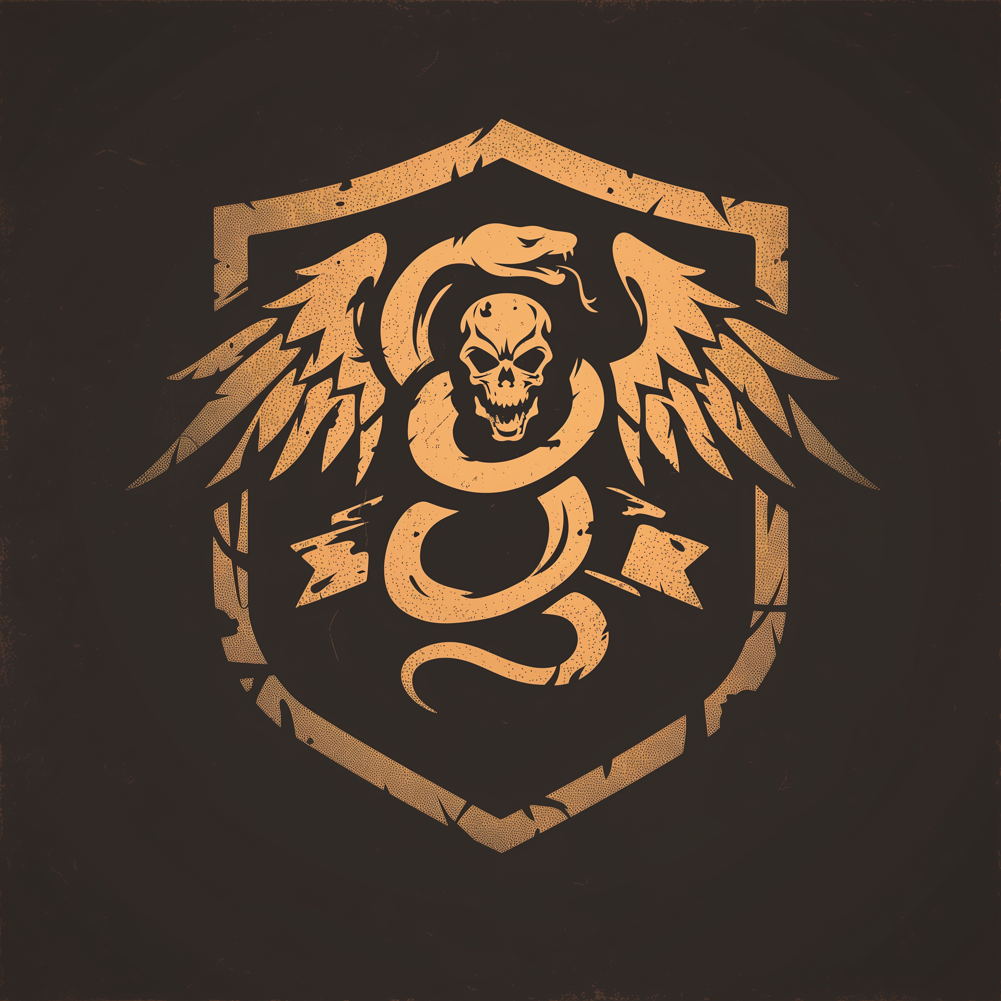
The Doom Raider’s modified Zhentarim sigil. A Winged Snake emerging from the Skull of a Lich
Davil Starsong is a business savvy sun elf and the charismatic leader of the Doom Raiders, a subfaction within the Zhentarim operating in Waterdeep. Known for his social graces and ability to forge profitable ventures, Davil holds the title of Master of Opportunities and Negotiations within the Black Network. He conducts his business affairs from the Yawning Portal Inn, a renowned tavern that serves as both his residence and base of operations.
Fractured Zhentarim: Davil’s subfaction vs. new Urstul’s zealot subfaction
The majority of the Zhentarim in Waterdeep act as a morally flexible mercenary faction of mercenaries led by the savvy entrepreneur Davil, who I often call the “Doom Raider Zhents” since Davil’s party is called the Doom** Raiders. The DRZ considers themselves the “true” Zhents and aspired to make their branch of the Black Network into a legit Mercenary Guild.
(**A “Doom” is the lair of a lich, thus the lich skull 💀 on their logo and the skulls prestidigitated to the top of the winged snake messengers in my canon)
On the other side of the Zhents, there is a newly formed extremist faction of the Zhentatim that I call the “Zhent Zealots” led supposedly by Urstul Floxin (actually Manshoon) who want to “make Zhentil (Keep) Great Again”. Which is apropos since Manshoon (well, his clone) is the real subfaction leader of the Zhent Zealots who first founded the Zhentarim Centuries).

Who are Davil’s Doom Raiders?
The Doom Raiders are a formidable group of former adventurers who earned their name by plundering liches' lairs, known as "dooms." Transitioning from their perilous exploits, they joined the Zhentarim and established a foothold in Waterdeep around 1489 DR. The core members include:
- Yagra Stonefist: A Half-orc brawler who is Davil’s bodyguard (technially Yagra is strangely NOT specified as a Doom Raider by the official module, but she is the epitome of a Doom Raider and should be treated as such. See section on Yagra for more info).
- Istrid Horn: A dwarf cleric overseeing financial operations.
- Tashlyn Yafeera: A human fighter responsible for arms and mercenaries.
- Skeemo Weirdbottle: A rock gnome wizard specializing in magical supplies.
- Ziraj the Hunter: A half-orc assassin renowned for his marksmanship.
This faction aims to legitimize their operations, distancing themselves from the more violent elements within the Zhentarim.
How I chose to present Davil’s goals and motivations:
Davil is used in the official Module for his role as the leader of the less fanatical, more mercenary-guild like faction of the Zhentarim in Waterdeep, aka the normal Zhentarim you’d see in the other cities around FaeRun, those that don’t have a secret Manshoon clone to reclaim ownership of his long lost Black Network.
His goal is ultimately to get rid of the Zhent Zealots run by Urstul Floxin, who is merely a pawn of Manshoon who first founded the Zhentarim way back in the day. He wants to establish the Zhentarim as a legitimate Mercenary Guild in Waterdeep since technically Waterdeep does not currently have a formal Mercenary Guild.
Davil secretly has a target on his back by the Xanathar Guild via Meloon Wardragon. Meloon is secretly controlled by one of Nihiloor’s Intellect Devourers and will attempt to take Davil out the first chance he gets.
In my module I had The Doom Raider Zhentarim (DRZ) aka the majority of Zhentarim in Waterdeep pledge their loyalty to Davil and therefore adopt his Doom Raider version of the Zhentarim logo. Instead of just a winged snake the Doom Raider Zhents have a winged snake coming out of a Skull intended to be a Lich’s Skull.
Emphasize how upset Davil is by the splinter faction of Urstul’s zhents starting the Gang War that has broken out with the Xanathar Guild, and how they are ruining all of the hard work he did to build up a good reputation amongst the masked lords and the Waterdhavian Guilds and Nobility.
Control of the Zhentarim could very easily shift to Urstul's splinter faction if it becomes publicly known that Manshoon has returned (the man he was cloned from did found them after all), so if Manshoon becomes desperate he may come out of hiding to usurp control to make a larger play. For example, if Davil is arrested after the Gralhund Villa incident he might make his move to pounce on the opportunity to deploy Zhents to put pressure on the party at the Vault of the Dragon. Getting the Staff of Ahghairon would allow him to blackmail Waterdeep's safety by disbanding the Dragon Ward.
There are 4 missions given out by the Black Network provided by the module. I won’t outline all of them here but I do think the ones I would use are the Elf Killer and then possibly combine the 2nd and 4th missions to reveal how Skeemo has betrayed them when the players find out Davil was arrested suddenly.
The module suggests Davil would be arrested after the bloodbath of Gralhund Villa where the Zhents are all brought in for questioning, but you can still make it canon that it was Skeemo that tried to sell out Davil to weaken them vs the Xanathar and sowing chaos amongst the Black Network.

Introducing Davil
- Setting the Scene: The Yawning Portal is a hub for adventurers and an ideal location for the party to encounter Davil and his crew. His approachable demeanor makes it easy for characters to engage with him. He uses the YP as his headquarters to constantly gather information and also to take a crack at plundering the Undermountain himself. His latest missions have drawn him close to finding a Lich’s Doom and he’s far too busy with these quests and the Urstul’s splinter faction causing problems to take on a personal quest such as finding the Elf Killer (more on that Hook later).
  - I chose to have a private meeting on the 2nd Floor that was curtained off to still allow them to peek at the fight unfolding below on the first floor with the Yagra tavern brawl. Later when the party returned from a mission I had Davil in a more formal conference room they rented out for the evening, also located on the 2nd floor. His permanent room was a suite on the 3rd floor, the man’s got deep pockets.
- Yagra Stonefist's Role: Yagra, a half-orc and Davil's loyal bodyguard, can serve as a bridge between the players and Davil. An initial interaction, such as assisting Yagra in a tavern brawl against Xanathar Guild members, can establish rapport with her and lead her to thank them by asking them if they need work since she’d love to introduce them to Davil.
  - Note: The module doesn’t technically include Yagra in the list of Doom Raiders, but in my canon she was his “right-hand woman” almost like a 2nd in command. She is not featured in the artwork for the Doom Raiders either, so it can be assumed that she was not a member of the Doom Raiders before they joined the Zhentarim
  - Also in the module it implies the Doom Raiders have given,
- Presenting the Elf Killer Quest: With Davil occupied by internal Zhentarim matters, he seeks external help to investigate a series of murders targeting individuals with elven heritage in the Dock Ward. He offers the task to the party, providing them with details and resources to pursue the investigation.
  - The details (my homebrew):
    - Elves have been murdered at night and found beheaded the next morning
    - He provides a list of people (include one high born pure blood elf, one sailor who was friends with those at the Muleskull, and another woman who was just an average waterdavian who worked in another ward but was visiting the Dock Ward for the festival.
    - The list will show there doesn’t seem to be anything other in common other than they were elves in the Dock Ward / Mistshore area (where Soluun is spending his shore leave stalking)
    - The beheadings are tricky because it’s not immediately obvious they were elves (no ears without a head) but everyone who knew these people knew them to be an elf.
    - The reason I chose beheadings was because then the police couldn’t simply cast Speak With the Dead
    - Soluun was feeding the heads to a mimic dumpster who is known to lurk around the alley behind Muleskull Tavern
Roleplaying Tips for Davil and making Yagra more important:
- Characterization of Davil: Portray Davil as charming and eloquent, embodying the sophistication of a sun elf without arrogance. His interactions should reflect his strategic mind and genuine interest in fostering beneficial relationships.
  - Note: I chose to give Davil an Irish accent. When my player Scott cheekily asked “What accent is that?” I replied “What are ya talkin about, this is a Sun Elf accent”.
  - The real reason I went with the Irish accent is so I could show the players the little charm bracelet Davil with trinkets from monsters they’ve slain, and he says “They’re always after me Lucky Charms” 😉
- Leveraging Yagra's Connection: If a player character has a background link to Yagra, use it to naturally introduce the party to Davil and the Doom Raiders. Alternatively, assisting Yagra during the tavern altercation can serve as a catalyst for this introduction.
  - For example, in my campaign Hurk and Yagra had an half-orc equivalent to a “One Night Stand” when they fought in the Arenas of Blood 10 years ago. He helps her in the bar fight and she introduces him to Davil since he mentions he’s in Waterdeep looking for work (mercenary work)

Rewards & Next Steps After the Elf Killer Quest
Once the party successfully captures or eliminates the Elf Killer, Davil Starsong will reward them with gold, magical items, and deeper connections within Waterdeep’s power structure. The following are common ways to transition the party from this quest into broader faction politics and city intrigue:

1. Payment and Favor with the Doom Raiders
- Davil pays the party handsomely (usually around 250 gp) and acknowledges their skill. (I had this amount on the Trollskull Alley bulletin board’s wanted poster that Davild had posted for the Killer)
- If the party handled the situation with discretion and competence, Davil offers them more high-level jobs, integrating them into the Doom Raiders’ future plans.
- If the City Watch recognizes the party’s role in capturing the killer, Davil uses this success as an argument for why the Zhentarim should be seen as a legitimate security force.

2. Testing the Prototype “Ball of Monster Pocketing”
- As a bonus reward, Davil provides the party with a prototype magic item, a precursor to the Iron Flask known as the Ball of Monster Pocketing.
- The Doom Raiders, having raided lich lairs, want to test its ability to trap powerful creatures, and the party becomes their test subjects.
- This sets up potential future encounters with creatures escaping from the ball, creating an ongoing magical mystery.
I thought it was a fun idea to include a prototype of the Iron Flask (The Ball of Monster Pocketing) that’s basically a Pokeball prototype. The Iron Flash is too powerful and is basically the Master Ball variant that could be what they are trying to replicate.

Davil’s Role in the Campaign Going Forward
After the Elf Killer arc, Davil Starsong can continue to serve as a faction leader, employer, or political ally, depending on how the party interacts with him.

1. Political Intrigue in Waterdeep
- Davil sees the Field of Triumph Tournament as an opportunity to gain legitimacy for the Zhentarim.
- He warns the party about Xanathar’s involvement in underground fights, setting up a potential undercover mission in Skullport.
- If the party aligns with Davil, they can help him oust Urstul Floxin’s faction, reinforcing his vision for a lawful mercenary guild.

Future Story Beats Involving Davil
The War for Zhentarim Leadership – Davil tasks the party with sabotaging Urstul Floxin’s operations, gathering dirt on Manshoon’s plans, and ensuring his Doom Raiders take full control of the Zhentarim in Waterdeep. This could be complicated by his arrest (outline by the module), but honestly I don’t think his arrest adds much if you can’t also homebrew a way for the players to bust him out of jail.

Conclusion
Davil Starsong offers a unique faction storyline that allows for deep political intrigue, faction wars, and morally complex decisions. Whether as an employer, ally, or manipulative mastermind, he can keep the party engaged far beyond the initial Elf Killer quest.
By integrating him into Waterdeep’s guild conflicts, Zhentarim power struggles, and high-stakes magical experiments, Davil can become one of the most influential NPCs in your campaign.
NOTES FOR FUTURE:
I will be making a follow up guide to outline the Elf Killer quest eventually, but for now you can check out my document on how to make Waterdeep’s police more interesting - it includes a beefed up version of Special Investigator Barnibus Blastwind with Willem DaFaol, a satyr who’s a satire of Willem Dafoal. Much more fun to run IMO, but the choice is yours whether to include.
Also note that players that might want to join the Zhentarim and possibly turn it into more of a Gang or more towards a respectable “by any means necessary” Mercenary Guild recognized by the Open Lord herself, Laeral Silverhand.
I have not yet developed this End Game option but if my players continue to strengthen their allegiance to the Doom Raiders Zhents I definitely will include my homebrew for this.

